ILCYM predictor: A web platform to predict pest risk and management recommendations optimized with AI

- Summary
ILCYM Predictor is an App web aims to enhance accessibility for plant health researchers through an interactive platform, enabling users to choose validated pest or natural enemy models. It generates maps and graphs for insect populations and risk factors in selected locations and time frames, with features like crop overlays and multi-insect selection.
This web platform connected to ILCYM 4.0 generates useful and fast results on pest risk and management, with easy access from any device with a web browser.
Link: https://ilcym.shinyapps.io/ILCYM_Predictor/

- Introduction
Regarding the use of pest risk prediction platforms, end users determine their usefulness through criteria such as the flexibility of the application, with easy-to-interpret results, that such results are convincing and finally that the results have a measurable positive impact. Then it was necessary to develop a web platform that makes geolocated risk predictions based on the ILCYM 4.0 program.
ILCYM software can generate information on the risk of pest establishment and population growth based on temperature data that can support various aspects of pest management. To make ILCYM predictions more accessible to plant health professionals, we propose to create an interactive website (using Shiny) where users can select validated pest/parasitoid models to generate maps or graphs of different population/parasitoid parameters. insect risk for selected locations/geographies. and time frames of interest, including options to mask with crop maps or multiple insect selection.

This web platform connected to ILCYM 4.0 generates useful and fast results on pest risk and management, with easy access from any device with a web browser.
The capabilities of ILCYM predictor are:
1. Simulation of insect population dynamics more friendly
2. Pest risk assessment and interaction with naturals enemies
3. Climate change adaptation planning based on availability of temperature data

The ILCYM predictor is a recently designed product that has been launched and is currently undergoing testing on the ILCYM website.
This platform offers valuable information for a variety of stakeholders in the agricultural sector:

- Researchers: can use the platform to evaluate and develop strategies for managing insect pests.
- Entomology students: The platform provides a valuable learning tool to explore the dynamics of insect pests.
- Farmers: can gain practical knowledge to make informed decisions about controlling insect pests in their fields.
- Policy makers and agricultural economists: The platform can inform policy development and resource allocation for sustainable pest management practices.

- Entry requirements

- Coordinates (to consult)
For location data, enter coordinates in decimal degrees. These coordinates should reference the WGS84 datum and include longitude, latitude, and an identifier (ID). The ID can indicate either a confirmed presence or a suspected presence (consultation record) based on your designation.
The data is entered without a header and in a text file (.txt), as follows:
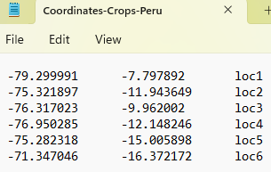
De igual forma se pueden agregar puntos georreferenciados de cualquier lugar del mundo, solo se necesita seleccionar una ubicación y seguidamente hacer clic en el botón “Add Point”, esta

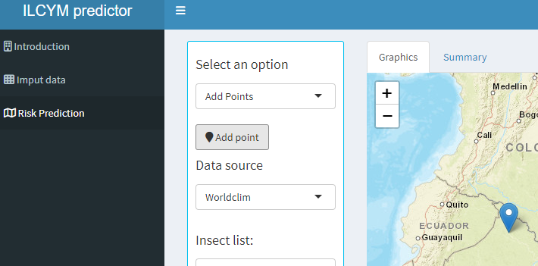

- Phenology
Multiple phenologies have been developed in ILCYM 4.0 that contain the complete modeling of an insect (pest or natural enemy). These will be part of a list that allows you to choose the pest or natural enemy to evaluate, so the prediction module will be able to determine the level of risk or possible control, according to the coordinates selected interactively.

- Climatic Data
Worldclim:
The temperature database is considered at a resolution of 2.5 minutes for the entire world, internally an estimate is made to obtain daily minimum and maximum temperatures.
https://www.worldclim.org/data/worldclim21.html

These temperatures are obtained from January to December for the year 2023 (last update made by its authors).
Nasa Power:
This is a NASA project focused on improving data on renewable energy worldwide. The POWER project seeks to create new data sets based on new satellite systems to have more precise information.
Data from the POWER project is available through the NASA POWER platform. This platform allows you to explore this data and download it. The available information includes variables such as air temperature and evapotranspiration, which is useful for agricultural and climate studies. NASA POWER:
https://power.larc.nasa.gov/

Cabildo de Tenerife:
Based on the agrometeorological stations of the Tenerife Island Council, air temperature records are published almost in real time, as well as other abiotic variables of importance in agriculture throughout the island.
https://www.agrocabildo.org/estaciones_comarca.asp

- Interface
This App has been developed with the “Shiny” package from R software for design and processing, there are 3 main modules, but the “Risk Prediction” module is the one that generates the simulations of the net reproduction rate (Ro) based on temperatures. registered fluctuations (according to the selection of climate data sources), according to the entered and selected coordinate; displayed on an interactive map generated by the “leaflet” package.

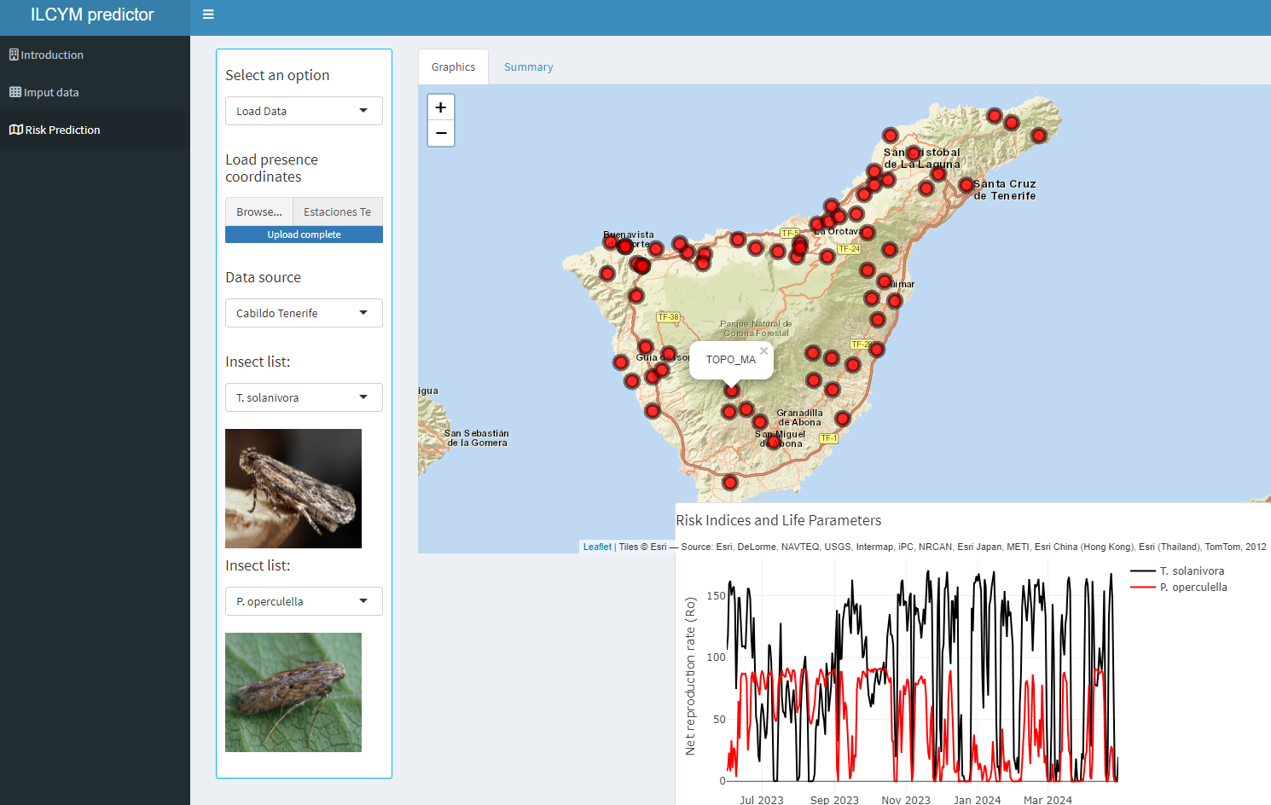

Two different insects can be chosen from separate lists of pests and their natural enemies.
The net reproduction rate (NRR) helps us understand the impact of temperature on these insects. NRR estimates the survival and reproduction potential of new females, which directly relates to the insect's "action level" - its potential to cause economic damage. By comparing the NRR of two chosen insects over time, we can identify which species poses a greater threat and determine the most effective control method, whether preventive, reactive, or a combination of both.
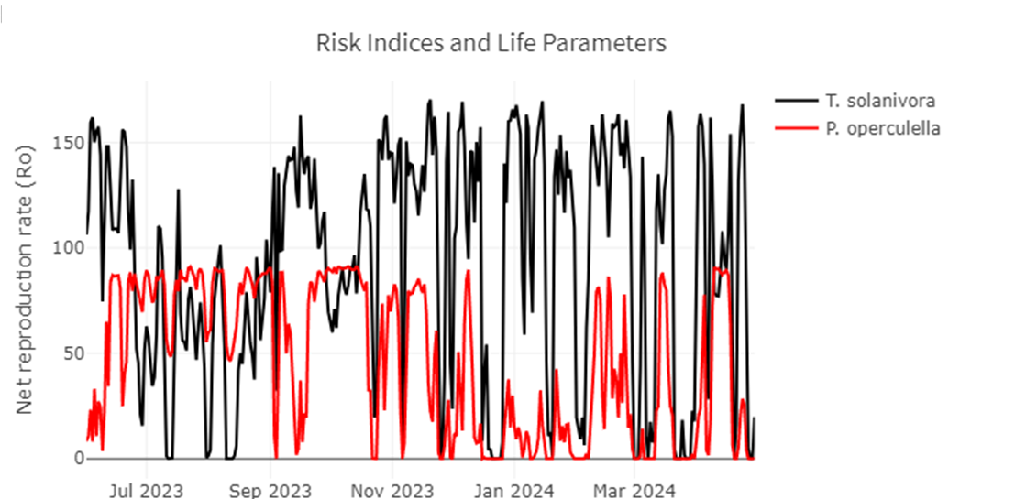

- Next steps (in validation process)
App web "ILCYM Predictor" will generate automatic recommendations with ChatGPT 4, on optimal management according to the evaluation of the estimated risk of insect pests with other related variables (altitude, precipitation, phenological stage of the crop, etc.); performs temporal and spatial evaluations interactively.
The real spatial distribution of the selected species can be visualized, in addition to being constantly updated with the help of users (after verification and citation).

